RxImage Image Layouts
The RxImage pill images have 8 different layouts. The layouts are specified in the <Layout> or <Class> tag in the XML (each image will have one, but not both of the tags). The following are examples of each type of layout.

MC_API_NLMIMAGE_V1.3
This is an image returned by the RxImage API. The image does not contain any metadata.
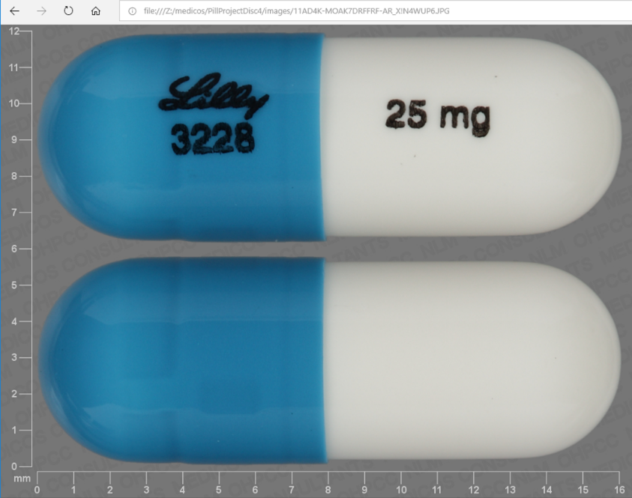

MC_API_RXNAV_V1.3
This is an image returned by the RxImage API. The image contains metadata.
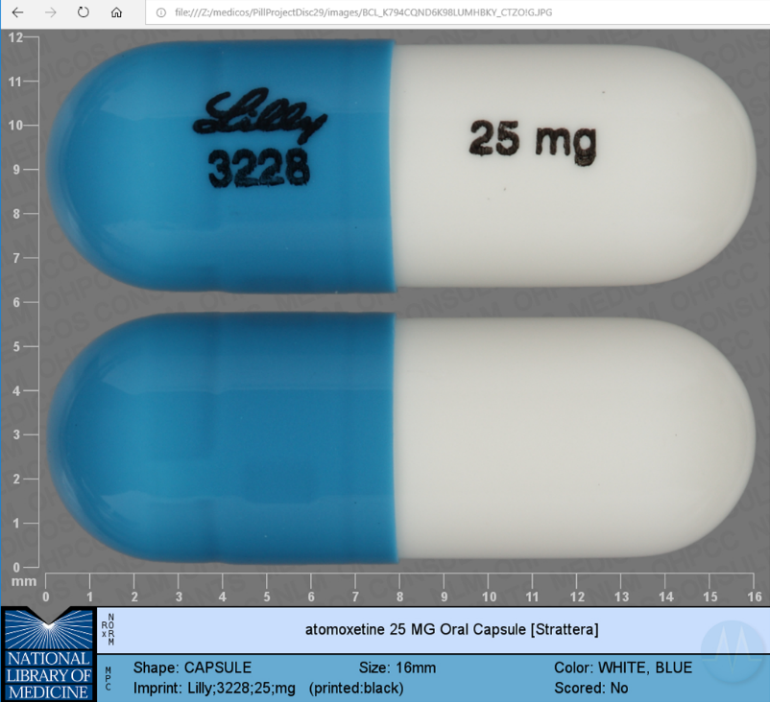

MC_C3PI_REFERENCE_SEG_V1.6
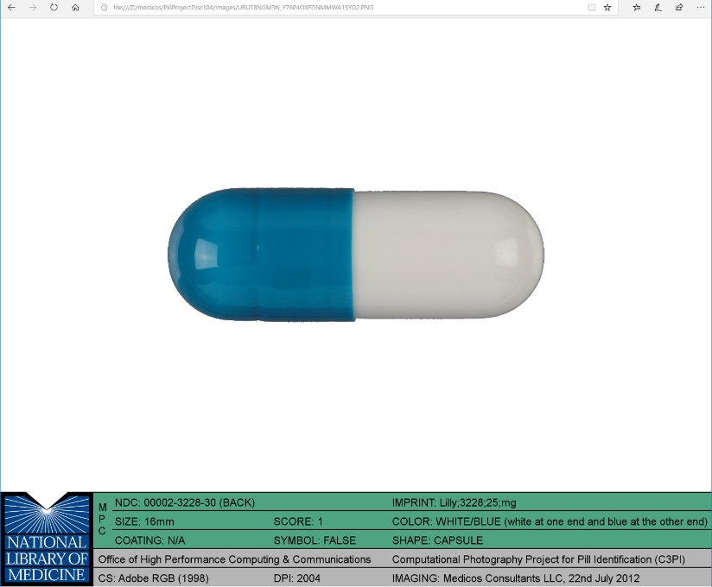

MC_CHALLENGE_V1.0
This is an image used in the NLM pill challenge contest.
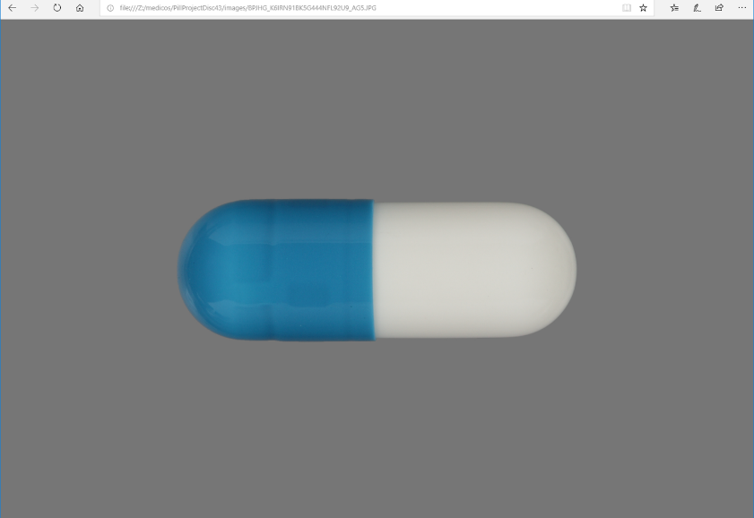

MC_COOKED_CALIBRATED_V1.2
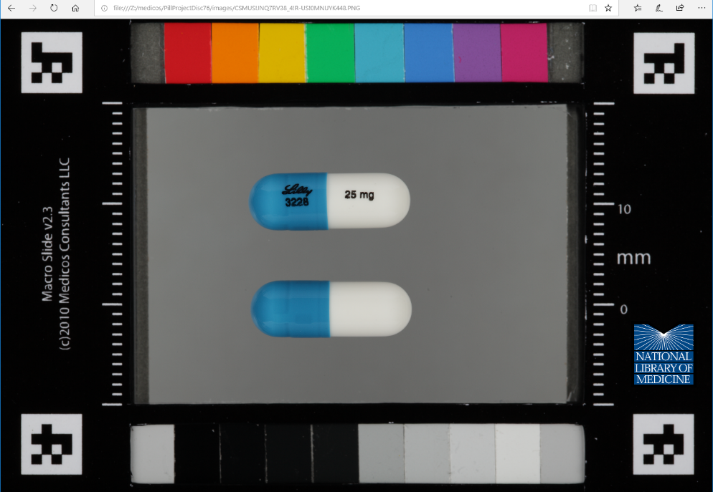

MC_SPL_IMAGE_V3.0
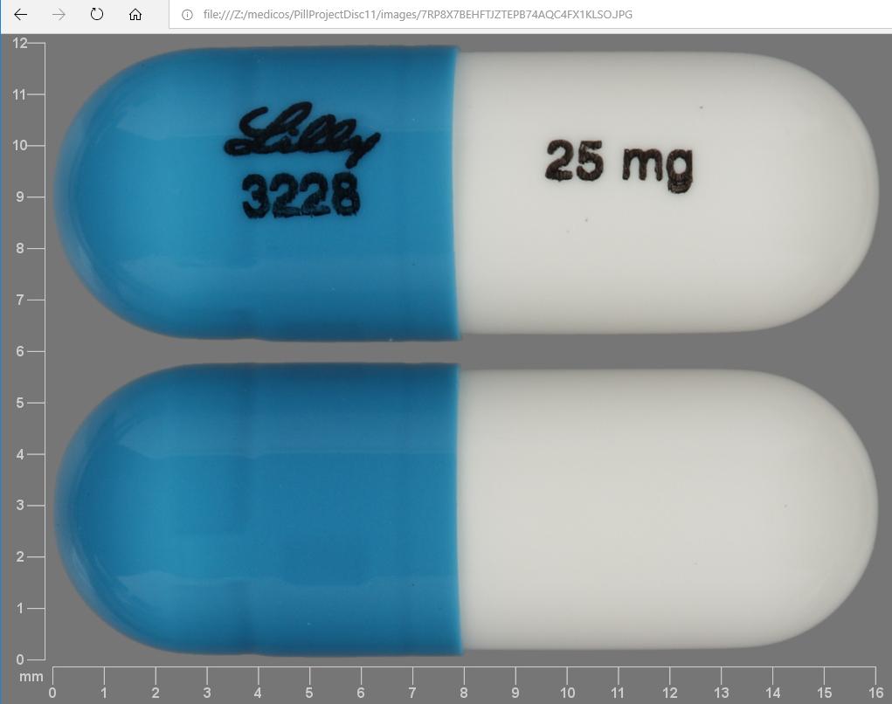

C3PI_Reference
The image file has a .CR2 extension.

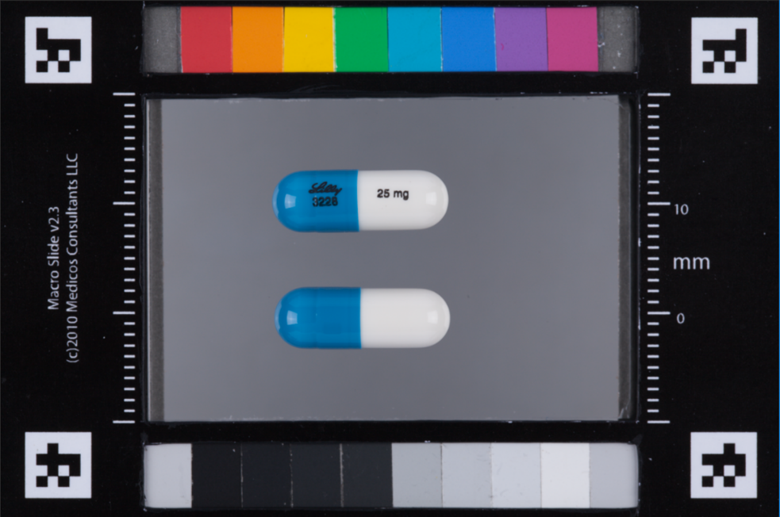

C3PI_Test
This is a test image. Background and lighting can vary from image to image.
